Mitchels H

1.16 e-3 -4.24 e-3 9.89 e-3

5.98 e-4 2.80 e-3 -1.43 e-3

-1.49 e-6 9.99 e-7 2.59 e-3

Yours is this but inverted in terms of negative positive

Mitchels aspect ratio

526 x 945

526 / 945 = 0.55661375661

Mitchels output

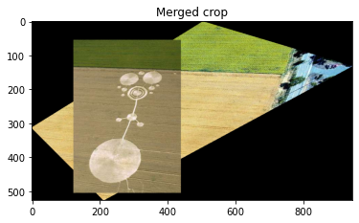

merge_image[abs(int(min(np.amin(scaled_h[1]),0))): abs(int(min(np.amin(scaled_h[1]),0))) + ref_image.shape[0], abs(int(min(np.amin(scaled_h[0]),0))):abs(int(min(np.amin(scaled_h[0]),0))) + ref_image.shape[1]] = ref_image

input_coords = np.array([np.ravel(ycoords), np.ravel(xcoords)]).transpose()

Only changing the order of the inverse rows going into the interpolation method had any affect

